PEM100 LabVIEW Library rev1.2

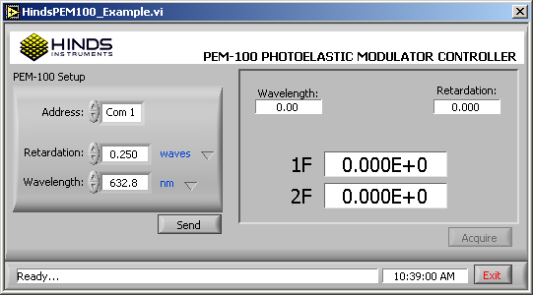

Revision History
Date | Version | Description | Author
05/24/2006 | 0.001 | Preliminary firmware release | Andy Leadbetter
10/03/06 | 1.2.100306 | Release for firmware update | Andy Leadbetter
Table of Contents
1. Introduction 3
2. Required Files 3
3. Connections 3
4. Software Overview 4
4.1 Starting 4
4.2 HindsPEM100_VI_Tree.vi 5
4.3 HindsPEM100_Example.vi 6
4.4 HindsPEM100_Setup.vi 7
4.5 HindsPEM100_Acquire.vi 8

Introduction
This document describes the upper level VIs in the PEM100 LabVIEW drivers rev 1.2. The software implements the PEM100 Hardware version: HW PN: 020-2650-989.000 and Firmware version: Start up header contains the firmware information in the following format: PEM-100 SW PN:025-1000-XXX.xxx. Where xxx is the suffix of the firmware for a specific head type. The software is not compatible with previous versions of the PEM100.
Suffix Wavelength Ret
-000 632.8 nm 0.25
-001 1550.0 nm 0.25
-002 10600.0 nm 0.25
-003 3391.0 nm 0.25

To find the hardware and firmware version of your PEM100: from the PEM100 menu select Sys.Config. and press the Enter button. Then select System Info. The screen will display the hardware and software versions.
The following sections describe the upper level VIs found in the PEM100 VI Tree.

Required Files
Below are the drivers needed to run the Hinds PEM100 VIs.
Name | Description
LabVIEW 7.1 | The development environment.
NI-VISA 3.3 | The VISA version the library was developed in.
PEM100_Visa_rev1.2.llb | The LabVIEW PEM100 VIs.

Connections
The PEM100 software requires an RS232 connection from the computer to the measurement hardware. The cable should have a DB9 female plug on both ends.

The COM settings are:
Item
COM Port | 1-10
Baud Rate | 2400
Data Bits | 8
Parity | NONE
Stop Bit | 1
Hardware | NONE

The PEM100 controller must be in Remote mode for the software to communicate with the controller. To enter the remote mode: from the PEM100 menu select Mode Select then select Remote Control.

Software Overview
This section gives a brief description of the PEM100_Visa_rev1.2.llb upper level VI software.

Starting
Open the PEM100_Visa_rev1.2.llb library with LabVIEW 7.1 or higher:
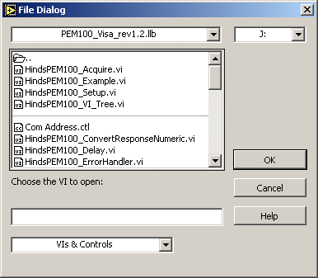
Figure 1 - Open Dialog

There are 4 upper level VIs:
- HindsPEM100_VI_Tree.vi
- HindsPEM100_Example.vi
- HindsPEM100_Acquire.vi
- HindsPEM100_Setup.vi

These are the VIs that most users will use to develop their programs.

HindsPEM100_VI_Tree.vi
This VI gives the user quick access and overview of the major VIs of the library.

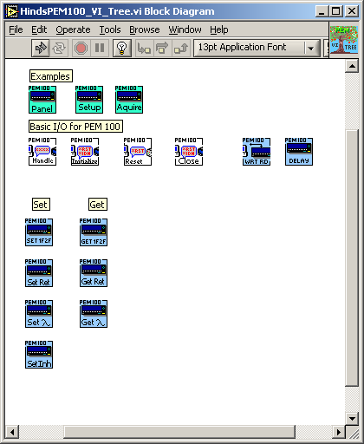
Figure 2 - VI Tree

HindsPEM100_Example.vi

The Example VI is an example of how the sub-VIs can be wired together to create an application. Open the VI and set the com port address to the computers port the instrument is connected to. Then select the retardation and wavelength. Press the run arrow. When the Send button is pressed the VI will send the setup information to the PEM100. After sending the initial setup information the Acquire button becomes active. Pressing the Acquire button retrieves the 1F, 2F, Wavelength and Retardation values and displays them. There is a 2 second settling delay between harmonic value requests. Press the Exit button to stop the VI.

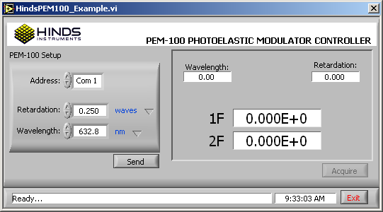
Figure 3 – Example

HindsPEM100_Setup.vi
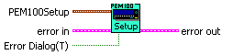
The setup VI is an example of how to set the com port address and PEM voltage by entering the retardation and the wavelength in the Strict Type Def cluster control shown in figure 4. The VI acquires a handle to the PEM100, sets the values and then closes the handle.
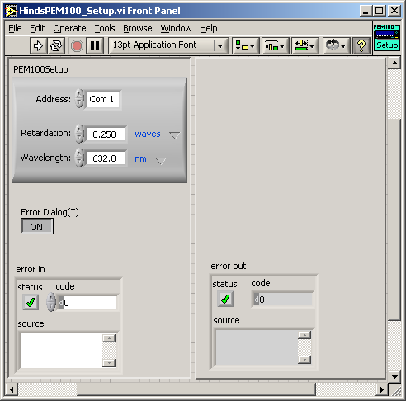
Figure 4 – Setup VI
Control Name | Description
Address | Select the com port that the instrument is connected to.
Retardation | Double: Enter in a retardation value in units of waves, radians or degrees. The default value is 0.250.
Ret Units | Ring U16Int: Select the type of units being entered in to the Retardation control. The default setting is waves.
Wavelength | Double: Enter a wavelength in units of nanometers, microns or wave number. The default value is 632.8.
Wave Units | Ring U16int: Select the type of units being entered in to the Wavelength control. The default setting is nm, nanometers.
Error Dialog(T) | The user can select whether the general error dialog window opens on an error or not.
Error In/Error Out | Standard LabVIEW error clusters.

HindsPEM100_Acquire.vi
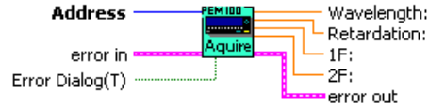
The acquire VI is an example of how to get a VISA handle and then use it to acquire the 1F, 2F, wavelength and retardation values. The VI acquires a handle to the PEM100, gets the values and then closes the handle.
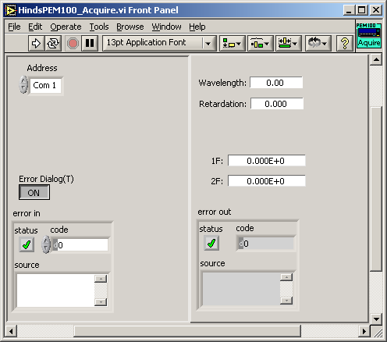
Figure 5 - Acquire VI
Control Name | Description
Address | uInt16: Select the com port that the instrument is connected to.
Error Dialog(T) | The user can select whether the general error dialog window opens on an error or not.
Wavelength: | Double: The Wavelength setting in nm.
Retardation: | Double: The Retardation in waves.
1F: | Double: The value received from the controller for the 1F harmonic.
2F: | Double: The value received from the controller for the 2F harmonic.
Error In/Error Out | Standard LabVIEW error clusters.

